My assignment of cs-unplugged activity:

Out of Data: Representing Information activities from cs-unplugged I found one activity interesting.

I am attaching the screen shot of this activity below. In which we need to develop a game for classification techniques.

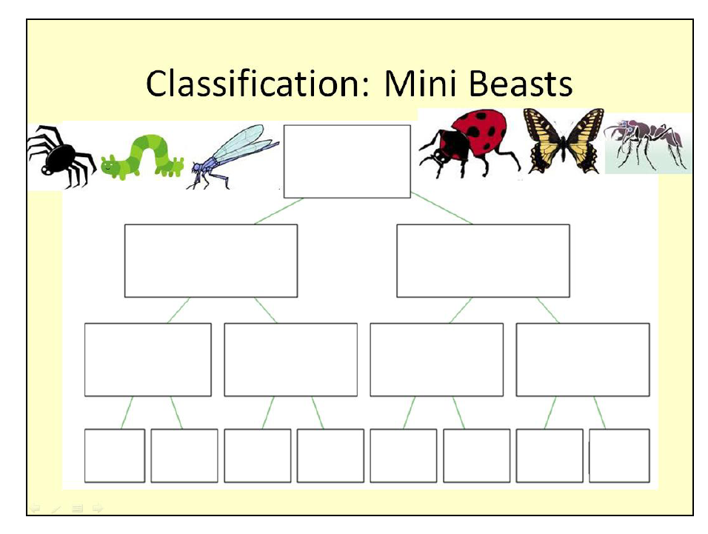

Here we can teach someone how classification works in database.

Please refer the link below for information about the activity.

<http://csunplugged.org/wp-content/uploads/2014/12/DatabasesUnplugged-Version2.pdf>

Flow of game:

1. Generate list of animals
2. Set time limit for game
3. Assign points for boxes
4. Assign points for time of finishing the game, for example if someone finished with 10 seconds left he/she will get extra points.
5. Ask students to drag the animal in boxes
6. The student who will make correct sequence of animals within less time will have more points will win the game.